**Wynncliff Site Plan**

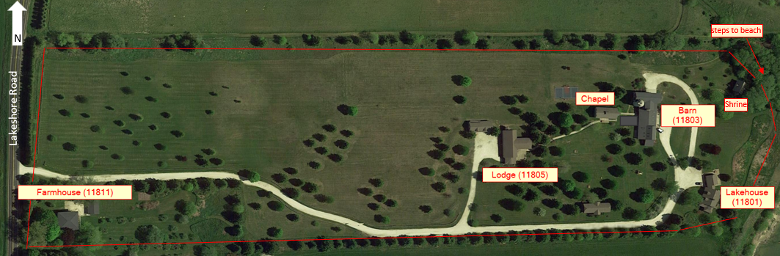

**Notes:**

Pack Cribs:

* 3 - Barn#7 closet (lower-level North)
* 1 - FH #2 closet (MBR)
* 2 - Lodge 1st floor closet in cross hallway
* 1 - Lodge basement classroom closet

1 full crib in FH #7 closet (MBR)

4 highchairs (2 with tray) – in Barn kitchen, under South Barn stairs, in Barn dining room

Rollaway beds: 10 (1-Barn #7 closet, 1-Barn #9 closet, 2-LH basement closet, 2-LH living room closet, 2-LH 2d floor closet, 2 Lodge basement closet)

Sleeping Capacity (56 beds…74 total including sleeper sofas and rollaway beds)

|  |  |  |  |  |  |  |
| --- | --- | --- | --- | --- | --- | --- |
| House | Bedrooms | Single/twin | Queen | King | Sleeper sofa | Notes |
| Chapel | 1 | 1 |  |  |  | Not shown in layouts on following pages but may be used as needed |
| Barn | 13 | 20 | 4 | 2 | 5 | sleeper sofas: lower-level common area, office, library, Room #3, Room #10 |
| Lakehouse | 7 | 7 | 2 | 1 | 3 | sleeper sofas: 1 in cottage common area, 2 in living room |
| Lodge | 8 | 10 | 2 |  |  |  |
| Farmhouse | 5 | 4 | 2 | 1 |  |  |
| **TOTALS** | **34** | **42** | **10** | **4** | **8** |  |

**BARN – South: first and second floor**

**North: first floor**

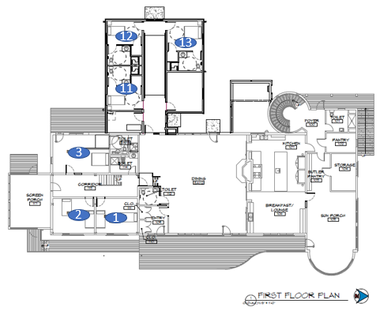

**library**

**Dining Room** (7 round tables x 6 chairs; 50 chairs total, two side tables)

50 chairs total

**Living Room**

**Kitchen**

*see next page*

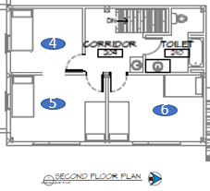

Office

|  |  |  |  |  |
| --- | --- | --- | --- | --- |
| **Rm#** | **Name** | **Beds** | | **Bath** |
| 1 |  | twin | | shared in hall, shower |
|  | lower bunk | |
|  | upper bunk | |
| 2 |  | twin | |
|  | lower bunk | |
|  | upper bunk | |
| 3 |  | king | | private, shower |
| 4 |  | lower bunk | #4 & #5 joined by open doorway  (fire egress) | shared in hall, shower over tub |
|  | upper bunk |
| 5 |  | twin |
|  | lower bunk |
|  | upper bunk |
| 6 |  | lower bunk | |
|  | upper bunk | |
|  | lower bunk | |
|  | upper bunk | |
| Note: Couch in room #3 and the Library each have a single sized pull-out bed. The couch in the office west of the living room has a pull-out bed. | | | | |
|  | | | | |

**BARN**

**North: lower level and second floor West**

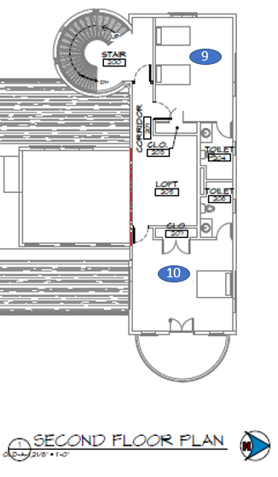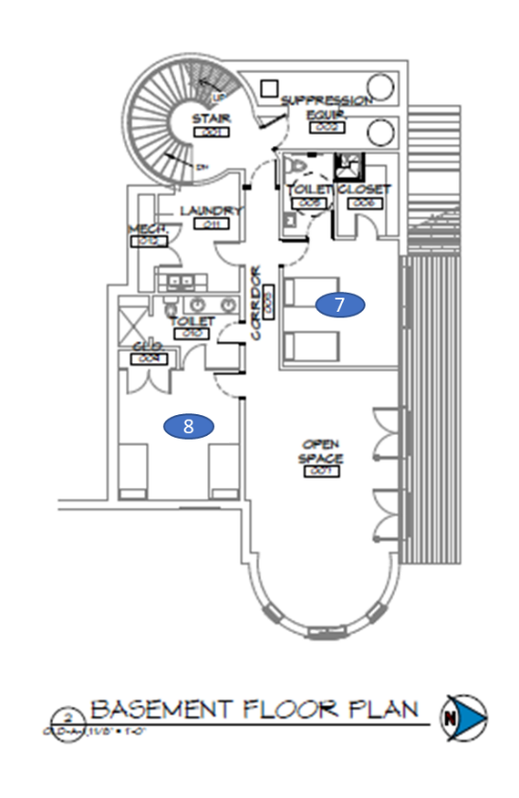

**Gathering space**

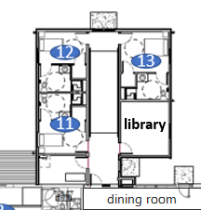

|  |  |  |  |
| --- | --- | --- | --- |
| **Rm#** | **Name** | **Beds** | **Bath** |
| 7 | *twin trundle under bed* | twin | private, shower/tub |
| *twin trundle under bed* | twin |
| 8 | *twin trundle under bed* | twin | private, shower |
| *twin trundle under bed* | twin |
| 9 |  | twin | private, shower/tub |
|  | twin |
| 10 |  | king | private, shower/tub |
| 11 |  | twin | private, ADA shower |
| 12 |  | twin | private, ADA shower |
| 13 |  | queen | private, ADA shower |

Note: There is one rollaway bed in the closet of room #7. #7 queen pull-out couch, pull-out twin sized couch in the lower level gathering space.

**LAKEHOUSE**

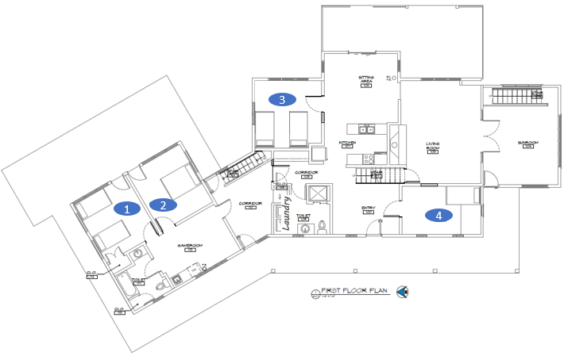

**Living Room**

**Sun room**

**Common area**

**“Cottage”**

**Dining Room**

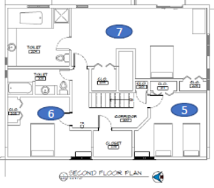

|  |  |  |  |  |  |  |  |
| --- | --- | --- | --- | --- | --- | --- | --- |
| **Rm#** | **Name** | **Beds** | **Bath** | **Rm#** | **Name** | **Beds** | **Bath** |
| 1 |  | twin | shared, shower over tub | 5 |  | twin | shared, in hall, shower over tub |
|  | twin |  | twin |
| 2 |  | queen | 6 |  | queen |
| 3 |  | twin | shared, in hall, shower over tub | 7 |  | king | private, shower |
|  | twin |  | | | |
| 4 |  | twin |

Note: There are two futons in the basement, two rollaway beds in the basement closet, two rollaway beds in the living room closet, two rollaway beds in the upstairs hall closet, both couches in the living room have pull-out queen beds.

**LODGE**

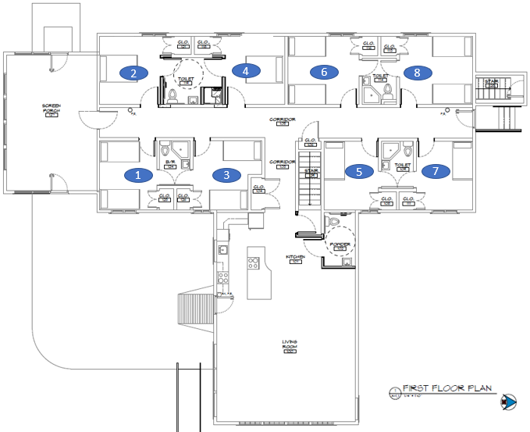

**Living Room**

**Kitchen / Dining**

|  |  |  |  |  |  |  |  |  |
| --- | --- | --- | --- | --- | --- | --- | --- | --- |
| **Rm#** | **Name** | **Beds** | **Bath** | **Rm#** | **Name** | **Beds** | | **Bath** |
| 1 |  | twin | shared, shower | 5 |  | twin | | shared, shower |
|  | twin |
| 3 |  | twin | 7 |  | twin | |
|  | twin |
| 2 |  | queen | ADA, shared, shower | 6 |  | twin | | shared, shower |
|  | twin | |
| 4 |  | queen | 8 |  | twin | A/C |
|  | twin |

Note: There are two futons in the basement, two rollaway beds in the basement across from laundry room.

**FARMHOUSE**

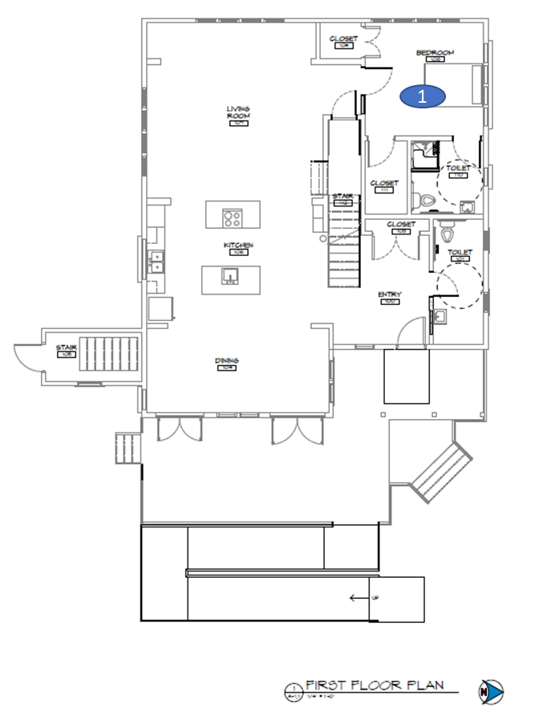

**Living Room**

**Dining Room**

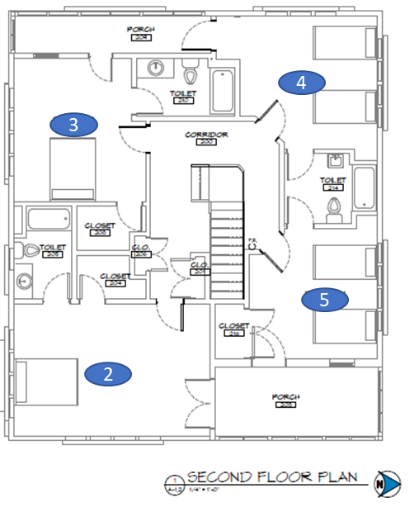

|  |  |  |  |
| --- | --- | --- | --- |
| **Rm#** | **Name** | **Beds** | **Bath** |
| 1 |  | queen | ADA, private, shower |
| 2 |  | king | private, shower over tub |
| 3 |  | queen | private, shower over tub |
| 4 |  | twin | shared, shower over tub |
|  | twin |
| 5 |  | twin |
|  | twin |

Note: There are two futons in the basement.